bdgex.eb.mil.br/cgi-bin/mapaindice?service=WMS&request=GetCapabilities
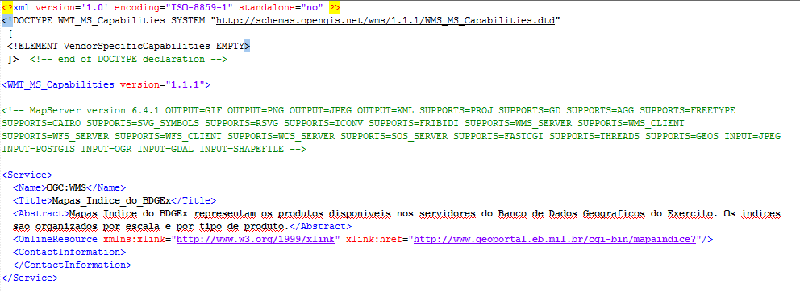

http://bdgex.eb.mil.br/mapcache?service=WMS&request=GetCapabilities
